Harrison County Community Resources

Provided by Harrison County Community Foundation
Update as of 4-22-2020

During these challenging times, we hope to share important community updates in Harrison County to help people get connected with resources. Together, as a community, we can help each other during these tough times.

If you have community resources to share, send information in a few sentences in an email to Sarah Travis at saraht@hccfindiana.org by Tuesdays at 4pm. The list of resources will be shared on Fridays.
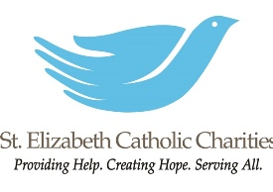
Our shelters remain open and we have expanded some of our criteria on a case by case basis to be able to safely offer housing for more women and children during the pandemic.
We have eliminated rent payments for Affordable Supportive Housing and Family Stability Programs and are providing all residents with food, household supplies, paper and cleaning products that are needed as well as appropriate PPE.

Staff are working remotely and are available by phone at 812-949-7305 or by email at info@stecharities.org to respond to critical needs and communications.

Harrison County Indiana Covid-19 Resources

Click the link above to check out the Harrison County Indiana Covid-19 Resources Facebook page which is a partnership between Harrison County Government, the Community Foundation, and other county community organizations to provide a central information source for citizens of Harrison County Indiana during the COVID-19 outbreak.

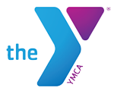

YMCA of Harrison County

Due to another extension of the stay at home order, the newest tentative reopening date is now Friday, May 1, 2020.

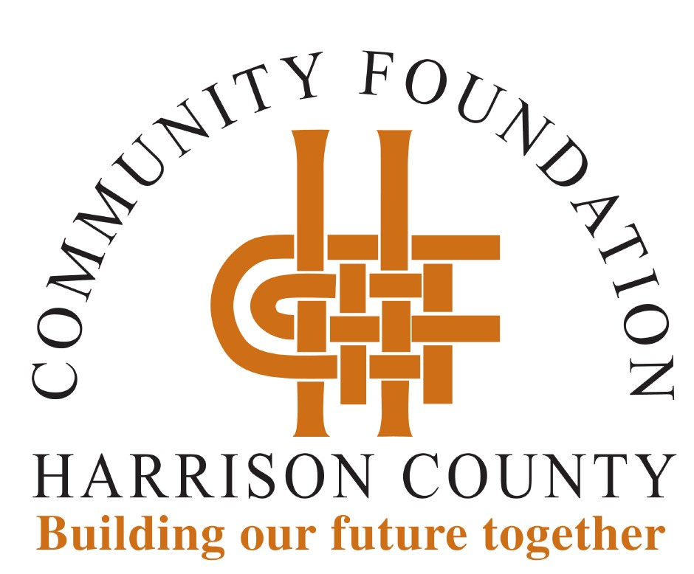

Harrison County Community Foundation (HCCF) is partnering with Blue River Services (BRS), the Boys and Girls Club of Harrison County (BGC) and the YMCA of Harrison County to cover childcare costs for healthcare, emergency and essential workers.

Employees working in essential services can register their children for free childcare by directly contacting the providers.

BRS Rainbow's End at 310 South Capitol Avenue in Corydon, parents can register by calling Rainbow's End at 812-738-1979. Rainbow’s End will accept children from one year through 12 years old.

BGC at 134 Jenkins Court NE in Corydon is conducting registration on its website, www.hc-bgc.org. The BGC is accepting youth from one year to age 18.

The YMCA at 198 Jenkins Court in Corydon, is also conducting registration on its website, www.ymcaharrison.org. Registration must be completed at least 12 hours in advance.

The Harrison County Community Foundation (HCCF) COVID-19 Relief Fund will provide resources to our nonprofit organizations serving Harrison County residents as they address immediate and long-term needs. Every dollar received will be used to provide assistance.

If you would like to join us in helping meet the need, you are invited to make a gift to the HCCF COVID-19 Relief Fund. Gifts may be made online at hccfindiana.org or by mailing a check to HCCF, P.O. Box 279, Corydon, IN 47112. Make checks payable to HCCF with "COVID-19 Relief Fund" noted.

Our office is closed; however, staff is working remotely. If you have questions, staff can be reached by email at staff@hccfindiana.org or by phone at 812-738-6668 to access voicemail. We will get back with you as quickly as possible.

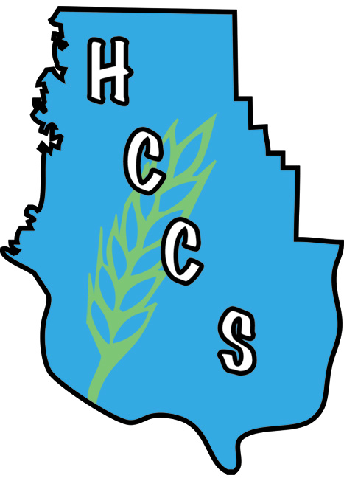

Harrison County Community Services
Operations Update

Hello to all our Harrison County Neighbors. One of our primary missions is to help fight hunger in Harrison County. During this difficult time, we are here to help EVERYONE who needs food, to get it. If you, your family, friends, or neighbors are in need, please direct them to Harrison County Community Services.

We are still open 8:30am-4:30pm, Monday-Friday. In order to comply with CDC and Indiana State Health Department guidance, no clients will be allowed in the building. Clients waiting for food and other services are asked to practice social distancing and remain in their vehicles as much as possible. If you need food or other assistance such as help with rent, utilities and prescriptions, please call us at 812-738-8143 when you get to the parking lot and someone will assist you over the phone.

Resource Links

Listed below are resources regarding the COVID-19 crisis.

Food Stamp (SNAP) Application
https://fssabenefits.in.gov/bp/#/

Indiana Family and Social Services Administration
Get information about SNAP, Health Benefits, Childcare, etc. at https://www.in.gov/fssa/

Indiana Department of Workforce Development
File for Unemployment benefits
https://www.in.gov/dwd/3474.htm

Indiana State Department of Health
https://coronavirus.in.gov/

Change in Hours

All three CHOICES offices are open with temporary limited hours. We hope to add more hours and services beginning May 11.

Reach any location at 812-941-0872 or send an email to info@choiceslrccares.org.

New Albany W & Th. 10 am - 3 pm
Corydon Mon. 10 am - 3 pm
Salem Tues. 10 am - 3 pm

Needed Items

CHOICES continues to serve clients with supplies during this time, plus we have had the opportunity to serve many other families. Diapers in size 6 is our greatest need. Once we re-open for classes and shopping, our kiddos will be needing spring and summer clothes. The current stock of smaller sizes is good, but we anticipate a need for toddler clothes 2T-4T.
Seeing Hope in 2020 Banquet

The Seeing Hope in 2020 Banquet will be held Tuesday, October 20 at Plantation Hall at Huber's Winery. If you made reservations for the initial spring date, your fall spot is secure!
CHOICES' staff is available to clients for prayer and encouragement via phone.

