Harrison County Community Resources

Provided by Harrison County Community Foundation
Update as of 4-28-2020

During these challenging times, we hope to share important community updates in Harrison County to help people get connected with resources. Together, as a community, we can help each other during these tough times.

If you have community resources to share, send information in a few sentences in an email to Sarah Travis at saraht@hccfindiana.org by Tuesdays at 4pm. The list of resources will be shared on Fridays.

Helping Hoosiers live better.

2-1-1 is a free and confidential service that helps Hoosiers across Indiana find the local resources they need. Dial 2-1-1 to connect with a navigator. We're here for you 24 hours a day, 7 days a week.
eek.
Information about novel coronavirus (COVID-19).

Please contact us by:

Website: https://in211.communityos.org/
Phone: Dial 2-1-1 or 1-866-211-9966
(available 24/7)
Text: Text your ZIP Code to 898-211
(available Mon-Fri 8am-4pm)

Harrison County Indiana Covid-19 Resources

Click the link above to check out the Harrison County Indiana Covid-19 Resources Facebook page which is a partnership between Harrison County Government, the Community Foundation, and other county community organizations to provide a central information source for citizens of Harrison County Indiana during the COVID-19 outbreak.

For the latest on class offerings, upcoming events and test sessions check us out on social media!

Library facilities are closed but we are open 24/7 with virtual services. Plus, free wifi outside all of our branch locations in the parking lots.

Visit HCPL’s Public Safety Page for library closure and COVID-19 updates at
https://hcpl.lib.in.us/public-safety-update/

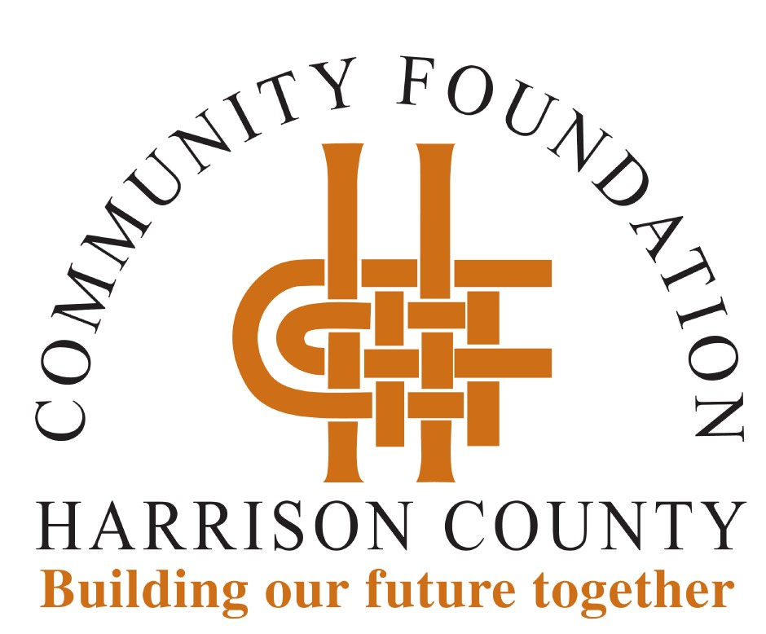

Our office is closed; however, staff is working remotely. If you have questions, staff can be reached by email at staff@hccfindiana.org or by calling 812-738-6668 to access voicemail. We will get back with you as quickly as possible.

Essential Workers

Employees working in essential services can register their children for free childcare by directly contacting the providers below.

BRS Rainbow's End at 310 South Capitol Avenue in Corydon, parents can register by calling Rainbow's End at 812-738-1979. Rainbow’s End will accept children from one year through 12 years old.

BGC at 134 Jenkins Court NE in Corydon is conducting registration on its website, www.hc-bgc.org. The BGC is accepting youth from one year to age 18.

The YMCA at 198 Jenkins Court in Corydon, is also conducting registration on its website, www.ymcaharrison.org. Registration must be completed at least 12 hours in advance.

The Harrison County Community Foundation (HCCF) COVID-19 Relief Fund will provide resources to our nonprofit organizations serving Harrison County residents as they address immediate and long-term needs. Every dollar received will be used to provide assistance.

If you would like to join us in helping meet the need, you are invited to make a gift to the HCCF COVID-19 Relief Fund. Gifts may be made online at hccfindiana.org or by mailing a check to HCCF, P.O. Box 279, Corydon, IN 47112. Make checks payable to HCCF with "COVID-19 Relief Fund" noted.

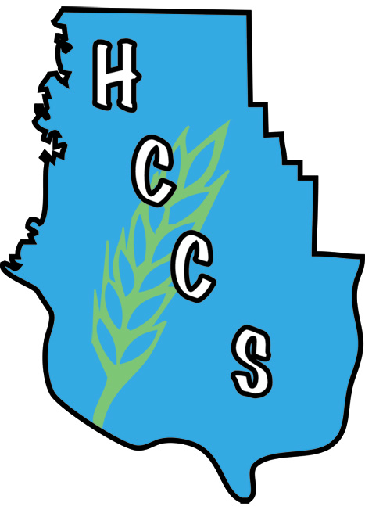

Harrison County Community Services

One of our primary missions is to help fight hunger in Harrison County. During this difficult time, we are here to help EVERYONE who needs food, to get it. If you, your family, friends, or neighbors are in need, please direct them to Harrison County Community Services.

HCCS is still open 8:30am-4:30pm, Monday-Friday. In order to comply with CDC and Indiana State Health Department guidance, no clients will be allowed in the building. Clients waiting for food and other services are asked to practice social distancing and remain in their vehicles as much as possible. If you need food or other assistance such as help with rent, utilities and prescriptions, please call us at 812-738-8143 when you get to the parking lot and someone will assist you over the phone.

Harrison County COVID-19 Small Business Loan Program

This low interest small business loan program is designed to assist Harrison County’s smallest businesses hardest hit by the COVID-19 crisis with recovery efforts.

Funds (up to $7,500) are intended to be used by qualifying for-profit small businesses, located in Harrison County, with up to 30 employees, to assist with the economic downturn that has occurred due to the COVID-19 coronavirus pandemic. Non-profits can contact the Harrison County Community Foundation for COVID-9 emergency grant assistance.

For more information and to apply go to https://www.harrisonchamber.org/application-start/. The application deadline is Thursday May 7th, 2020.

Get Help with Your Food Budget
Staying within budget during an emergency can be difficult and stressful, but keeping your family properly fed is critical. Find out how to get nutritional assistance through government programs and other resources. Keep in mind these options to assist you in getting access to food:
- Apply for the SNAP program. Known previously as "food stamps," SNAP benefits can help you stretch your food budget if you have a low income.
- Enroll in food programs remotely, such as those for expecting mothers, families, seniors, and people with disabilities. Learn more about the Child and Adult Care Food Program (CACFP).
- Help can be provided at the state and local community level. Contact your state's social services agency for more information.

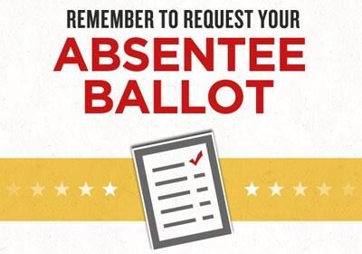

The primary election in Indiana will now be held on June 2. Because of the COVID-19 pandemic, the State of Indiana encourages you to vote by absentee ballot.
Please click here to access a printable application for an absentee ballot.

Mail your completed application to:
Harrison County Circuit Clerk Court
Courthouse, Room 203
300 North Capitol Avenue
Corydon, IN 47112-1155

Once the application is received, you will receive your ballot by mail with a prepaid envelope. Absentee ballot application requests are due by May 21. To request an absentee ballot application by phone, please call 812-738-4289.

At this time, Indiana still plans for in-person voting on June 2.

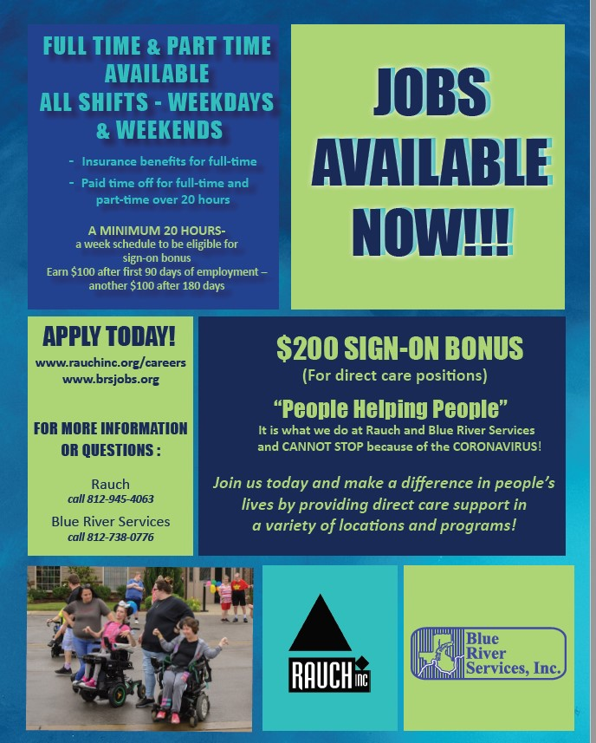

Change in Hours

All three CHOICES offices are open with temporary limited hours. We hope to add more hours and services beginning May 11.

Reach any location at 812-941-0872 or send an email to info@choiceslrccares.org.

New Albany W & Th. 10 am - 3 pm
Corydon Mon. 10 am - 3 pm
Salem Tues. 10 am - 3 pm

