Harrison County Community Resources

Provided by Harrison County Community Foundation
Update as of 5-6-2020

During these challenging times, we hope to share important community updates in Harrison County to help people get connected with resources. Together, as a community, we can help each other during these tough times.

If you have community resources to share, send information in a few sentences in an email to Sarah Travis at saraht@hccfindiana.org by Tuesdays at 4pm. The list of resources will be shared on Fridays.
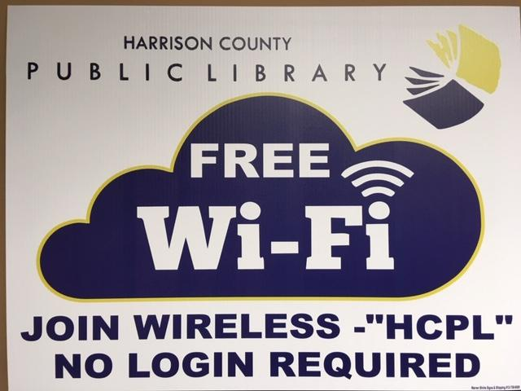

The Harrison County Public Library is offering contact free curbside pickup of books and DVDs.

Here is how it works:
• Patrons may place items on hold by using the online card catalog found at www.hcpl.lib.in.us or by calling their local library branch.
• The library will call patrons when items are ready to pick up.
• Patrons are asked to call the library when they park in the library lot.
• Staff will place the items in the car trunk, empty passenger seat or on the car hood.

For your safety and the safety of the library staff, patrons are asked to please remain in the car while your materials are delivered.

Any items to be returned should be placed in the library book drop before calling the library to pick up holds.

Look for updates on our website at http://www.hcpl.lib.in.us and our Facebook page at https://www.facebook.com/hcpl47112/

Library facilities are closed but we are open 24/7 with virtual services. Free WiFi is available outside all branch locations in the parking lots.

It is with much excitement we announce we will be reopening on Sunday, May 24! Our Sunday hours are noon - 5 pm.
During our closure, we are still providing childcare for essential workers and emergency personnel. For more information on this, please contact melliott@ymcaharrison.org.
We will be posting our May and June schedules, some upcoming program information, as well as restrictions and precautions we'll be taking upon reopening.
As a reminder, our social media pages are:
Instagram: ymca_harrison_county
Facebook: www.facebook.com/YMCAofHarrisonCounty/

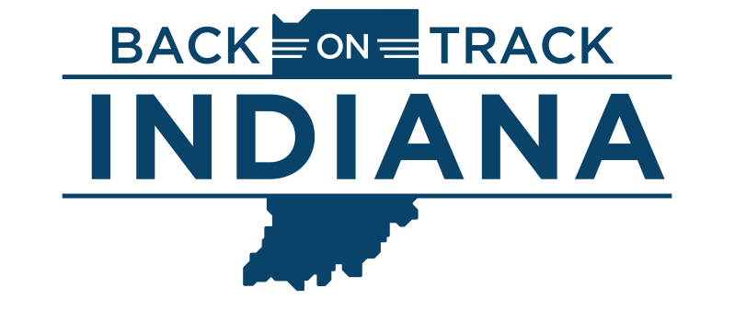
Indiana makes progress to get back on track
Gov. Eric Holcomb recently announced his Back On Track Indiana plan, which eases coronavirus-related restrictions on Hoosiers and businesses in five stages.
On Monday, May 4, Indiana's stay-at-home order and essential travel restrictions expired for 89 of the state's 92 counties. This means the majority of Indiana is now in stage two of the governor's plan in hopes of fully reopening by July 4. Marion, Lake and Cass counties are on a delayed timeline because of public health concerns.
FAST FACTS: Under stage two, retailers can now open at 50% capacity. Starting May 8, religious services can convene in-person with no restrictions on group sizes. Most restaurants can open at half capacity starting May 11, and hair salons and barber shops can open with restrictions. Social gathering limits also increase from 10 to 25. Click here to learn more about stage two.
Local ordinances stricter than the state's order remain in effect.
Hoosiers 65 and over and those with high-risk health conditions should still remain at home whenever possible. It is also recommended residents wear face coverings in public settings and continue to practice social distancing and good hygiene.

Economic Relief Grant available for Southern Indiana nonprofits

Lilly Endowment Inc. (the Endowment) and Metro United Way (MUW) are working together to provide COVID-19 relief aid for nonprofit agencies serving Clark, Floyd, and Harrison counties in Indiana. The Endowment granted $1.4 million to Indiana United Ways, who is partnering with MUW.

The COVID-19 Economic Relief Initiative Grant will provide immediate financial aid and long-term recovery to organizations and programs on the front lines of COVID-19. Efforts addressing access to food, housing and shelter will be the priority.

Applications will be accepted until funds are depleted. Priority areas of focus will continue to expand as identified areas of needs are addressed.

For more information about the RFP application and award process, please contact Pam Ottersbach at pam.ottersbach@metrounitedway.org. At this time, applications focusing on the priority areas of food and housing/shelter are being accepted.

To complete an online application, click here.

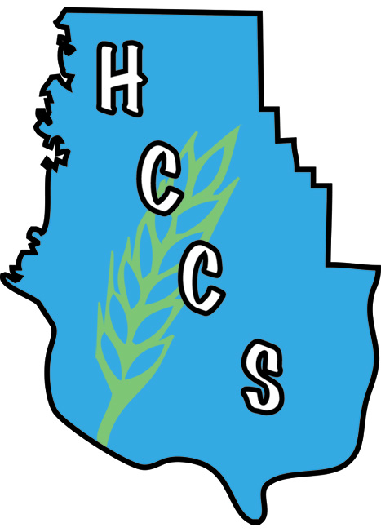

Harrison County Community Services

HCCS is still open 8:30am-4:30pm, Monday-Friday. In order to comply with CDC and Indiana State Health Department guidance, no clients will be allowed in the building. Clients waiting for food and other services are asked to practice social distancing and remain in their vehicles as much as possible. If you need food or other assistance such as help with rent, utilities and prescriptions, please call us at 812-738-8143 when you get to the parking lot and someone will assist you over the phone.

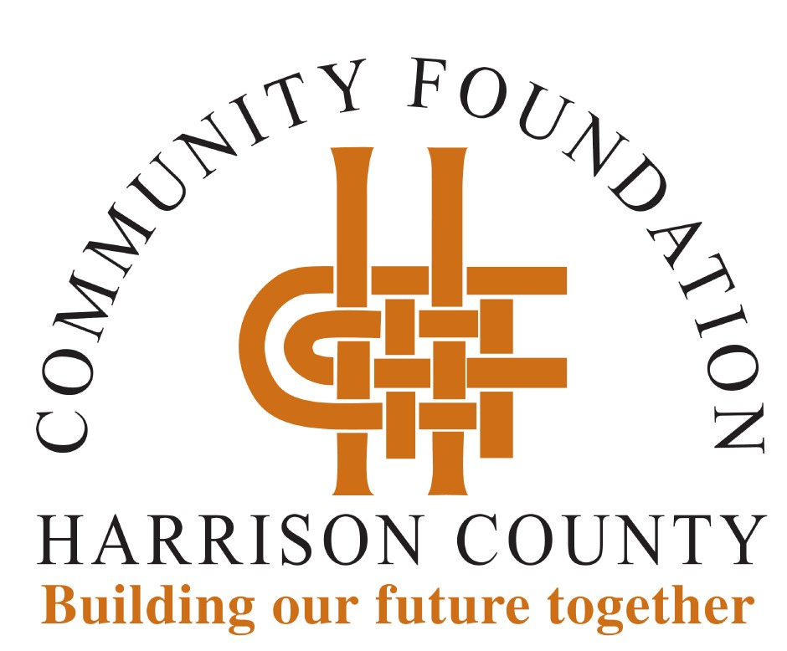

Our office is closed; however, staff is working remotely. If you have questions, staff can be reached by email at staff@hccfindiana.org or by calling 812-738-6668 to access voicemail. We will get back with you as quickly as possible.

The Harrison County Community Foundation (HCCF) COVID-19 Relief Fund will provide resources to our nonprofit organizations serving Harrison County residents as they address immediate and long-term needs. Every dollar received will be used to provide assistance.

If you would like to join us in helping meet the need, you are invited to make a gift to the HCCF COVID-19 Relief Fund. Gifts may be made online at hccfindiana.org or by mailing a check to HCCF, PO Box 279, Corydon, IN 47112. Make checks payable to HCCF with "COVID-19 Relief Fund" noted.

Indiana Foreclosure Prevention Network

The Indiana Foreclosure Prevention Network helps Indiana homeowners, who are at risk of foreclosure, through Indiana's Hardest Hit Fund ("HHF"). If you are an Indiana homeowner struggling to make your mortgage payment, Indiana’s HHF is here to help with mortgage payment assistance up to $30,000.
Indiana’s HHF is a FREE service for homeowners struggling to make their mortgage payments due to an involuntary financial hardship. The program helps homeowners stay in their homes, maintain an affordable mortgage payment and avoid foreclosure.
Indiana’s HHF is a statewide program funded by the U.S. Department of the Treasury to assist Indiana homeowners who are at risk of mortgage delinquency and foreclosure.
For more information visit their website at https://www.877gethope.org/can-i-get-help

We. Are. Open! Goodwill retail stores will be open to customers beginning Wednesday, May 6 from 10 a.m. - 6 p.m. This will be the first time the retail stores have been open to the public since March 26, due to the coronavirus pandemic.

Shoppers can expect the following changes in their shopping experience:
- Limit on the number of shoppers allowed in the store at any given time
- Face covering, such as a n95 mask or kerchief, recommended
- Fitting rooms are closed
- Social distancing markers throughout the store
- When dropping off a donation, place the donation in the appropriate box
We are excited to share we are moving from Emergency Only to a Soft open May 4th as the first step of a return to normal. We have implemented new protocols for the maximum safety for our patients. This includes increased sanitation measures and process changes to provide social distancing. We are committed to protecting our patient's and our staff's health by following the recommendations of the Indiana Optometric Association, the CDC and the directives of the state department of health and Governor Holcomb.
Eyecare Associates in New Salisbury 812-366-3147.

