Harrison County Community Resources

Provided by Harrison County Community Foundation
Update: 5-29-2020

As businesses are beginning to reopen and lives get a little more back to normal, this will be the last publication. We have enjoyed assimilating these resources and thank each one of you for passing this information on to the community.

The Harrison County Public Library is committed to serving its patrons and the community in a manner ensuring safety and health.

Beginning June 1 patrons can call their library branch to book 60-minute computer appointments.

To book a genealogy appointment contact the Frederick Porter Griffin Center at 812-738-5412.

HCPL continues service while physical facilities are closed to the public through the library website with access to eResources, eBooks, downloadable audio, virtual programming and free Wi-Fi available in each location’s parking lots.

The library currently offers contact free curbside pickup of books and DVDs and contact free document services including faxing, copying, printing, and scanning,
while protecting staff and the community.

HCPL will continue to determine what reopening will look like. In the coming months library service will not look exactly like it did before. Thank you for your continued patience and support.
We're Back!!!!
Throughout this shutdown, CHOICES has continued to serve families in need with diapers, wipes, formula, pregnancy tests and ultrasound. As of May 11, all three locations have re-opened our Step-Up Parenting Resource program. Beginning June 1, our nurses will also resume STD testing.

We are very excited to safely welcome moms and dads back into the buildings to receive education and encouragement. As we practice CDC protocols, we give "air hugs" from a distance and stand far away making googly eyes at our babies (since they can't see us smiling behind our masks). While this isn't the level of contact we are used to, it is heartwarming to hear, "Wow, we missed you all," from our clients.

Starting June 1st Hours
We are phasing back in staff, volunteers, and services in all three offices.
Reach any location at 812-941-0872 or send an email.
New Albany M, W, Th 10 am - 3 pm
Tues. 10 am - 8 pm

Corydon Mon. 10 am - 3 pm
Wed. 10 am - 6 pm

Salem Tues. 10 am - 3 pm
Thurs. 10 am - 6 pm

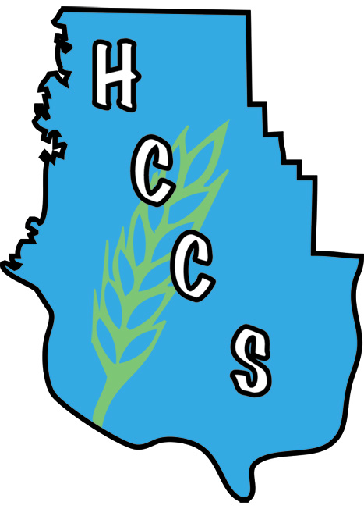

Harrison County Community Services

We are still operating Mon-Fri as a drive-up service only until further notice. If you are in need of food or other services, or are dropping off a donation, call us at 812-738-8143 when you get to the parking lot. We are still putting clothing racks outside for clients to browse through weather permitting.

Empty Egg Cartons needed: If you have any empty egg cartons laying around, we would appreciate donations for our food pantry! With spring here we are getting a lot of farm and other donated eggs that are loose and need to be repacked so that they can be given out. Thank you!

Mobile Food Pantries - In conjunction with Dare to Care, HCCS holds two Mobile Food Pantries the 2nd Saturday of each month. Morning distribution begins at 10am at Unity Chapel United Methodist Church in Ramsey. Afternoon distribution begins at 2:00pm at the South Central School campus on Hwy 11 in Elizabeth. Mobile pantries will also operate as drive-thru with added precautions due to COVID-19. Clients are asked to stay in vehicles and your food box will be placed in your trunk. Participants must bring a photo ID. The next Mobile Food Pantries will be June 13, 2020.

With schools closing, Junior Achievement is providing free online resources to teachers and parents. We are doing this so our kids can spend more time planning for and dreaming about tomorrow, and less time worrying about today. We are committed to doing this until we can all be certain again.

Click on the following link for the free online resources for Junior Achievement programs, https://www.juniorachievement.org/web/ja-usa/tomorrow .

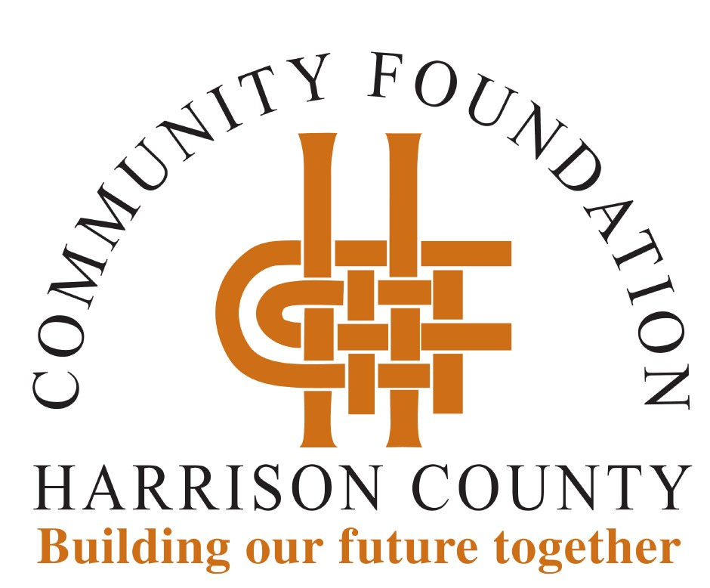

Our office is closed; however, staff is working remotely. If you have questions, staff can be reached by email at staff@hccfindiana.org or by calling 812-738-6668 to access voicemail. We will get back with you as quickly as possible.

The Harrison County Community Foundation (HCCF) COVID-19 Relief Fund will provide resources to our nonprofit organizations serving Harrison County residents as they address immediate and long-term needs. Every dollar received will be used to provide assistance.

If you would like to join us in helping meet the need, you are invited to make a gift to the HCCF COVID-19 Relief Fund. Gifts may be made online at hccfindiana.org or by mailing a check to HCCF, PO Box 279, Corydon, IN 47112. Make checks payable to HCCF with "COVID-19 Relief Fund" noted.

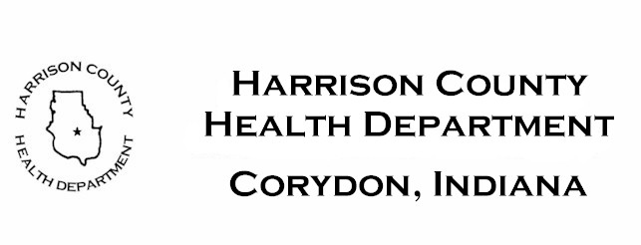

COVID -19 TESTING BY APPOINTMENT

COVID-19 testing by appointment only, Wednesday May 13, 2020 thru Saturday, June 6, 2020. No walk-ins accepted.

Where? Harrison County Fairgrounds, 341 S.
Capitol Avenue, Corydon.

Appointment times available - 8:00 AM thru 8:00 PM.

The site will operate Tuesday thru Saturday, May 25 and Tuesday thru Friday. June 5 from 8:00 AM to 8:00 PM.

You must make an appointment online at https://lhi.care/covidtesting or by calling 888-634-1116.

For Indiana residents:
* who are symptomatic OR
* those who have been in close contact with a COVID-19 positive person OR
* individuals with underlying health conditions OR
* individuals age 65 or older OR
* essential county employees.

Insurance information will be collected, if available. Testing is free of charge.

** NOTE: Since this testing is done by a private company, results may be longer in coming back to the health department. **

Respond to the 2020 Census, help our community
If you have not responded to the 2020 Census, please act soon because our community depends on it.
You can fill it out online now at 2020Census.gov, over the phone at 844-330-2020 or by mailing back the questionnaire sent to households.
The census is a count of the nation's population and the data is used to distribute billions of dollars in federal funding to communities to support education, housing, health and public safety. Census data also impacts strategic planning decisions about statewide job training, locations of new businesses and public transportation projects.
Everyone is required to fill out the census every 10 years by law, and the information is kept confidential. Personal information cannot be used against respondents by any government agency or court.
Self-responses are due by Oct. 31, 2020. Click here to learn more about the 2020 census.

